**IFT 466 Advanced Computer Networks**

**Lab 1  
EIGRP – Basic Configuration**

After you complete each step, put a ‘√’ or ‘x’ in the completed box

**Objective**Demonstrate how to configure the Enhanced Interior Gateway Routing Protocol (EIGRP) in a network topology.

1. Setup up the following topology on Packet Tracer

****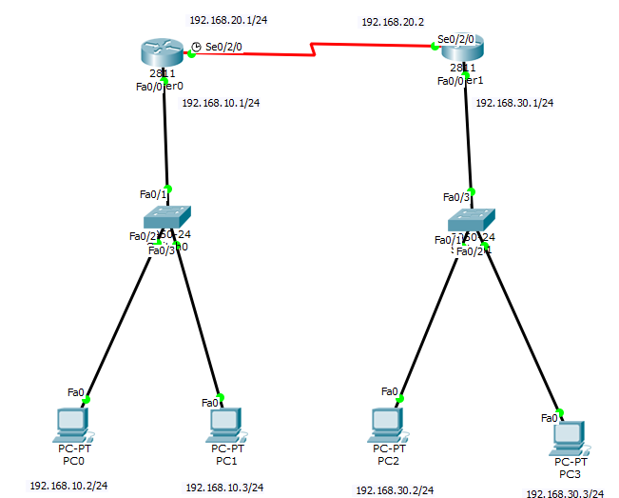

✓

1. Configure both the PCs and routers with the layer 3 addressing all on appropriate interfaces



✓

1. Confirm the following

PC0 can ping its default gateway

PC0 cannot ping PC2

 ✓

1. We will now assign the EIGRP protocol on both routers

We will enable the EIGRP routing process on each router using AS number 10

**Question**  
What is the range of numbers that can be used for AS numbers?   
  
**1- 65535**

We will then advertise directly connected networks via the network command







✓

Step 1: open CLI mode in the router.

Step 2:

**R0**

* Router> Enable
* Router# Config Terminal
* Router(config)# router eigrp 10
* Router(config-router)# network 192.168.10.0 0.0.0.255
* Router(config-router)# network 192.168.20.0 0.0.0.255
* Router(config-router)# do wr

**R1**

* Router> Enable
* Router# Config Terminal
* Router(config)# router eigrp 10
* Router(config-router)# network 192.168.20.0 0.0.0.255.255.255.0
* Router(config-router)# network 192.168.30.0 255.255.255.0
* Router(config-router)# do wr

1. Run the show ip route command on R0/R1 and now both routers have now learned of the extra network

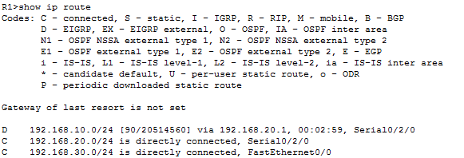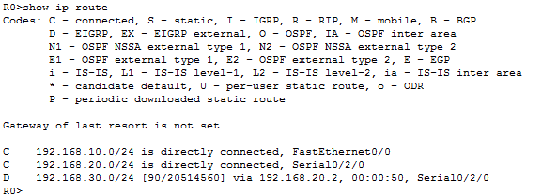



✓

Now try and ping PC2 from PC0 and it should work



✓

